|  |
| --- |
| **E:\My Documents\Desktop\Logo_FPT_University_doc.jpg** |
| Capstone Project Plan Management |
|  |
|  |
| **Rental House Finding System Team | FPT University** |
| **Hanoi, 28th Feb 2013** |

|  |
| --- |
|  |

Table of Contents

2.1. Problem Definition 1

2.1.1. Project Name 1

2.1.2. Problem Abstract 1

2.1.3. Project Overview 2

2.1.3.1. Proposed System 2

2.1.3.2. Boundaries of the System 3

2.1.3.3. Development Environment 3

2.2. Project organization 3

2.2.1. Software Process Model 3

2.2.2. Roles and Responsibilities 4

2.2.3. Tools and Techniques 5

2.3. Project management plan 0

2.3.1. Tasks 0

2.3.2. Task Sheet: Assignments and Timetable 0

2.3.3. All Meeting Minutes 0

2.4. Coding Convention 0

# 2.1. Problem Definition

## 2.1.1. Project Name

The formal and official name for this Capstone Project is Rental House Finding System. The product name is “ainha.de”, but it might be changed in developing process.

## 2.1.2. Problem Abstract

After doing research and survey, the authors of this product realized that it’s necessary to build a system for Vietnamese users to find a house for lease, which is really high on demand now, especially, in big cities.

Currently, there are currently some other products providing quite the same services, however all of them have own advantages and disadvantages. The purpose of this project is to create a product that overcomes all those disadvantages and becomes a useful and effective tool to finding a house for lease.

Once completed, the product should possess the following characteristics:

+ Friendly interface, easy to use, can be used by all levels, all kinds of Internet users.

+ The main flow of searching for seeker and new posting for house owner should be simple and quick.

+ Advance Search function supports many extra options, full text search and suggestion for user to autocomplete necessary phase.

+ Having a good initial database with a considerable amount of information about house for lease.

## 2.1.3. Project Overview

### 2.1.3.1. Proposed System

The main system will be a website. There will be mobile applications running on popular operating systems as well in the future after deploying website successfully.

The system will provide the following main features in front-end:

* Everyone can visit the site and search houses for lease.
* Search function: Full text search with suggestion.
* Advanced Search function: detail search.
* Register new account & manage account profile.
* View profile of other users, and house posted by other users.
* Add a post to favorite list.
* Compare between houses in favorite list.
* Registered users can post a new topic about house for lease or share.
* Users can update and renew their house post.
* Some popular social networks may be integrated into the system for register, sharing and subscribing.

The back-end will allow the administrators to manage the most important activities as well as information on the site.

* Admin can manage Mod accounts and user account.
* Admin can manage categories.
* Admin can manage locations in the system: add, edit, and delete locations.
* Admin and Mod can manage all posts.
* Admin can manage payment.

### 2.1.3.2. Boundaries of the System

The system under development of this Capstone Project will include:

* The complete website
* All the process documents involved

### 2.1.3.3. Development Environment

Below is the list of hardware and software requirements needed for development environment:

#### Hardware requirements:

* + Personal computers for developing with the minimum configuration: 2 Gb of RAM, 50 Gb of hard disk, Pentium dual core 2.0 GHz.
  + A server computer for testing with the minimum configuration: 2 Gb of RAM, 50Gb of hard disk, Core 2 Duo 2.0 GHz.

#### Software requirements:

* + Operating System: Windows XP, 7/Windows Server 2008
  + Web Server: IIS 7
  + Framework: ASP.NET MVC3
  + IDE: MS Visual Studio 2010 SP1
  + DBMS: MS-SQL 2008
  + Source Control: GoogleCode & TortoiseSVN
  + API: GoogleMapsAPIv3, Facebook API

# 2.2. Project organization

## 2.2.1. Software Process Model

The process model used for developing this project is Waterfall model.

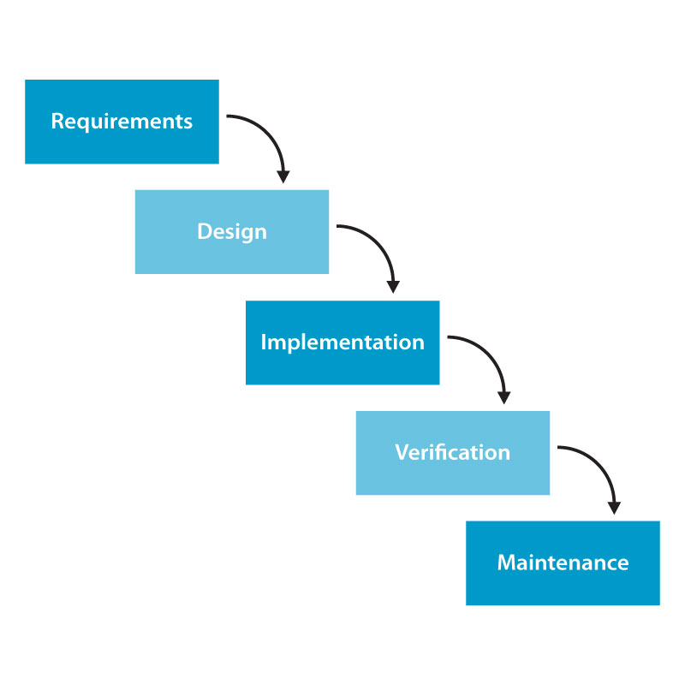

All the phases in the waterfall models are included in the scope of this project and are the responsibilities of the team.

## 2.2.2. Roles and Responsibilities

|  |  |  |  |
| --- | --- | --- | --- |
| No | **Full name** | **Role** | **Responsibilities** |
| 1 | Nguyễn Việt Nam | PM, Designer, Developer | * Create project plan * Managing process * Create document * Creating high-level design * GUI Design * Unit testing |
| 2 | Cao Quốc Hưng | Tech Lead, Developer | * Create detail design * Coding * Unit testing * Managing configuration * Deployment |
| 3 | Trần Thị Bích | Tester, BA | * Clarifying requirements * Create document, report * Creating test plan and system test cases * System testing |
| 4 | Võ Hoàng Việt | Developer | * Managing documents * Create documents, reports * Create detail system design * Coding * Unit testing |
| 5 | Nguyễn Tiến Chung | Developer | * Support create document * Coding * Unit testing * Deployment |

## 2.2.3. Tools and Techniques

* Front-end technologies: ASP.NET MVC3, MS-SQL, Ajax, jQuery, Google Map API, Facebook API, SMS Web Service
* Tools: MS Visual Studio 2010 SP1, MS-SQL 2008, MS Office 2007, Adobe Photoshop CS6.
* Architecture and design patterns: MVC

# 2.3. Project management plan

## 2.3.1. Tasks

|  |  |  |  |  |  |  |
| --- | --- | --- | --- | --- | --- | --- |
| **ID** | **Task** | **Description** | Deliverables | ResourcesNeeded **(Human/Duration)** | Dependencies and Constraints | Risks |
|  | Create project plan | Create project plan: Prepare plan for Capstone Project. | In the first stage, plan is about all overview of project. Divide project into small stages with corresponding duration.  After unifying all stages of project, creating plan for each stage: scope, resource, schedule, deadline…  **Deadline:** 11st Jan 2013 | All members must discuss about plan, to ensure that each stage fits time, resource of project.  **Duration:** about 1 week. | None | None |
|  | Create Software Requirements Specification | Create Software Requirement Specification (SRS) document | Software Requirement Specification included all Use Cases of Software product. It can be update during project, if necessary.  **Deadline:** 29th Jan 2013 | 5 persons/2 weeks | None | Due to time constrain, the team cannot make a deep research and wide survey to collect information about end-user’s needs. Almost requirements come from team members, conflicts may happen regularly. |
|  | Create Software Design Description | Create Software Design Description: Architecture design, detailed design, diagrams and design specification | **Deadline:** 1st Mar 2013 | 5 persons/2 weeks | Depends on the completion of SRS | Risks may include choosing inappropriate architecture and design patterns, causing the system hard to maintain, or causing high coding efforts. |
|  | Design Database | Create database design (logical and physical) | Logical database design: all tables and their relationship.  Physical database design: database in SQL Server 2008  **Deadline:** 19th Feb, 2013 | 5 persons/2 weeks | Depends on the completion of SRS | SRS may not be detailed enough to capture the business rules, causing the database design to be inappropriate or will be changed much in the future. |
|  | Layout Design | Design GUI for all interfaces of website. | HTML layout and CSS files  Images of all GUI  **Deadline:** 3rd Mar 2013 | 3 persons/1 week | None | None |
|  | Create System Test Cases | Create system test cases following SRS | **Deadline:** 2nd Apr 2013 | 1 person/2 weeks | Finish SRS | Lack test cases |
|  | Coding | Implement the system to reflect the requirements with output is: source code of the project, unit test reports | **Output:** Source code of the project, unit test reports.  Executable programs and source code before 2nd Apr 2013. | 5 persons/5 weeks | Finish of SRS, SDD, and Database design | Lack of Technical knowledge  Lack of experience in project management  Lack of skill to find and fix bug  Unit test may not be performed thoroughly causing spending more efforts in system test phase  May lack of time to implement all the requirements |
| Execute unit testing | Developer execute unit testing, follow System test cases | Deadline: 7th April 2013 | 4 persons | Finish coding process  Finish System Test cases | Lack of test cases  Lack of testing skill |
|  | System Test | Perform system test for the system | **Output:** System test report  Deadline: 14th April 2013 | 5 persons/2 weeks | Finish Coding  Finish System Test cases  Finish Unit testing | Lack of professional testers in team  Developers are also responsible for system testing, which may lead to compromise  Lack of skill on inputting data to test  Lack of skill in using test tool to test performance of website |
|  | Deployment | Deploy the system to the Internet  Output: Running website with domain and hosting | **Output:** Running website with domain and hosting  Before 18th Apr, 2013 | 2 persons/3 days | Coding and system test are finished, initial data is inputted | None |

## 2.3.2. Task Sheet: Assignments and Timetable

Please refer RHF\_Master\_Plan.mpp for more detail.

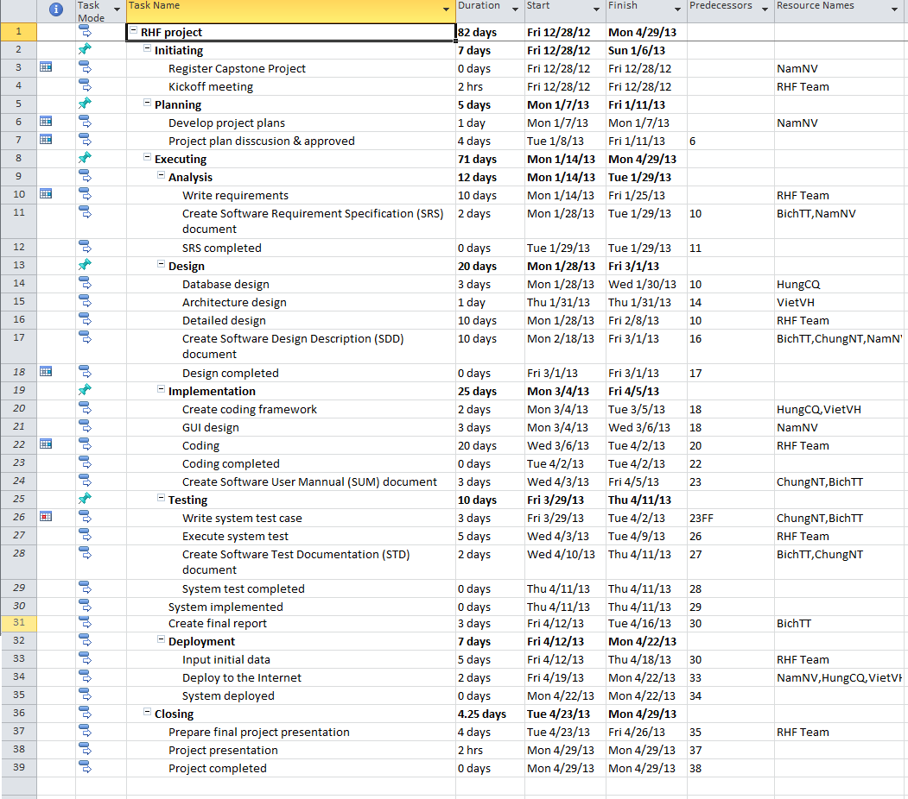

## 2.3.3. All Meeting Minutes

# 2.4. Coding Convention

Follow C# Standard Coding Convention at:

<http://msdn.microsoft.com/en-us/library/ff926074.aspx>